Code 1

This code plots volume growth rates of world merchandise exports and imports, yearly

The last quarter of 2020 data is filled by the mean of the first three quarters of 2020

Merchandise.R

Data website address:

http://unctadstat.unctad.org/wds/TableViewer/tableView.aspx?ReportId=99

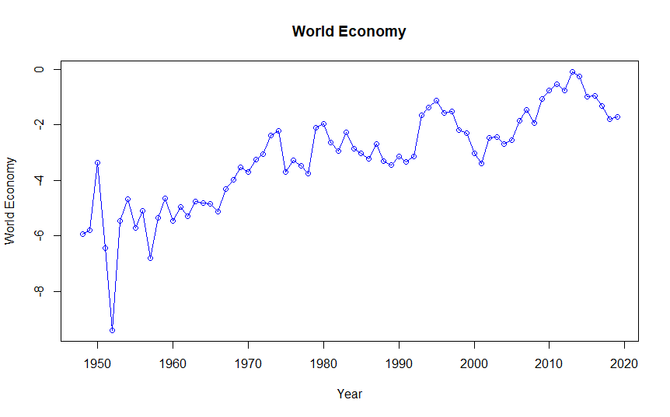

Code 2

This code plots volume growth rates of merchandise exports and imports in continent wise. Using this data the above world economy calculated

MerchandiseContinentWise.R

|  |  |  |  |  |  |
| --- | --- | --- | --- | --- | --- |
| **Continent** | **Africa** | **America** | **Asia** | **Europe** | **Asia and Oceania** |
| Northern Africa | Northern America | Central Asia | Eastern Europe |  |
| Sub-Saharan Africa | Latin America and the Caribbean | Eastern Asia | Northern Europe |  |
| Eastern Africa | Caribbean | South-eastern Asia | Southern Europe |  |
| Middle Africa | Central America | Southern Asia | Western Europe |  |
| Southern Africa | South America | Western Asia |  |  |
| Western Africa |  |  |  |  |
|  |  |  |  |  |

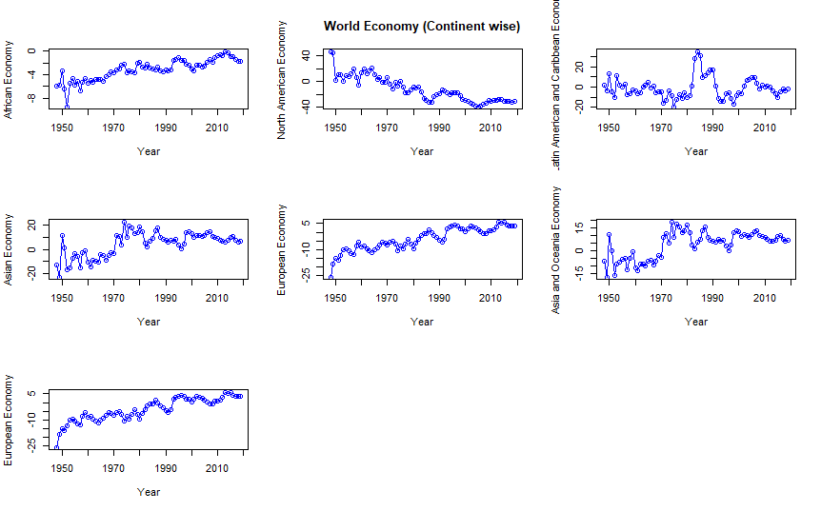

Code 3

This code calculates growth rates of merchandise in each continent.

MerchandiseEachContinent.R

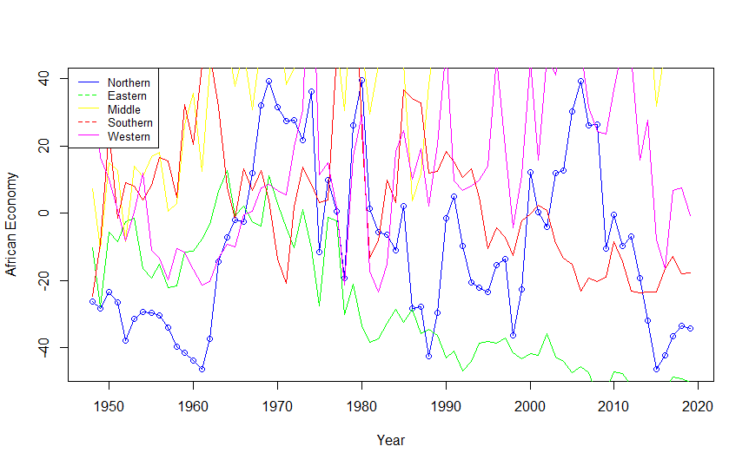

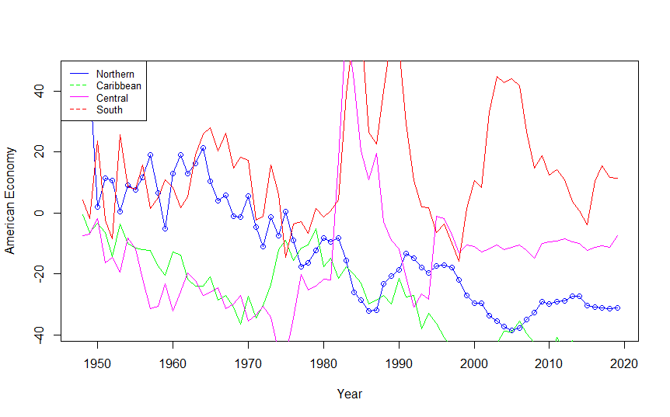

Code 4

This code used to process the data containing medical accessories sales between 2016 to 2020. The aim is to estimate the influence of the Covid on medical accessories sales.

GDP of various countries also considered to find the influence of Covid. The growth of Medical accessories, Food, Tropical beverages, Vegetable oilseeds and oils, Agricultural raw materials, Minerals, ores and metals, Minerals, ores and non-precious metals, Precious metals, and Fuels also studied.

MedicalAcc.R

PC.R